**DAY 5 – AZURE STORAGE**

File Storage is a data stored as a single piece of information inside a folder just like organized pieces of paper inside a folder.

Block storage chops the data into blocks and stores them as separated pieces. Each block of data is given a unique identifier, which allows a storage system to place the smaller pieces of data wherever is most convenient.

Object storage is a flat structure in which files are broken into pieces and spread out among hardware. In object storage the data is broken into discreet units called objects and is kept in a single repository instead of being kept as files in folders or as blocks on serers. Object storage requires a simple HTTP API, which is used by most clients in all languages.

Azure storage offers different access tiers so that you can store your blob data in the most cost effective manner.   
    Hot tier - An online tier optimized for storing data that is accessed or modified frequently. The hot tier has the highest storage costs, but the lowest access     costs.  
    Cool tier - An online tier optimized for storing data that is infrequently accessed or modified. Data in the cool tier should be stored for a minimum of 30     days. The cool tier has lower storage costs and higher access costs compared to the hot tier.  
    Cold tier - An online tier optimized for storing data that is infrequently accessed or modified. Data in the cold tier should be stored for a minimum of 90     days. The cold tier has lower storage costs and higher access costs compared to the cool tier.  
    Archive tier - An offline tier optimized for storing data that is rarely accessed, and that has flexible latency requirements, on the order of hours. Data in the     archive tier should be stored for a minimum of 180 days.

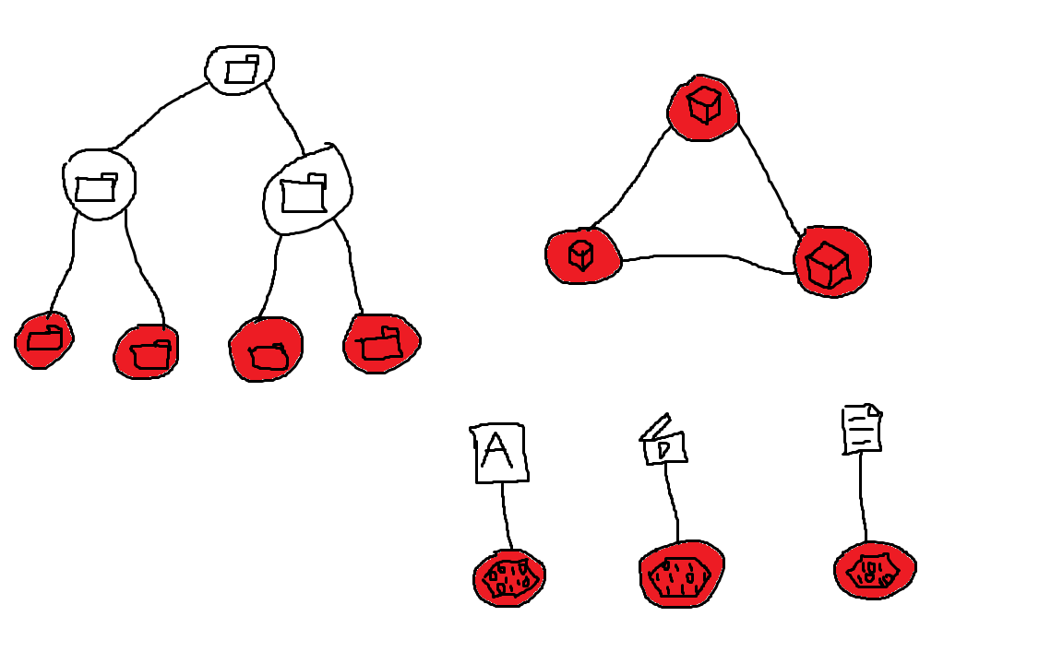

Azure queue storage is a service for storing large numbers of messages. You access messages from anywhere in the world via authenticated calls using HTTP or HTTPS. A queue message can be upto 64kb in size. A queue may contain millions of messages, up to the total capacity limit of a storage account. Queues are commonly used to create a backlog of work to process asynchronously.

**STEPS and Images –**

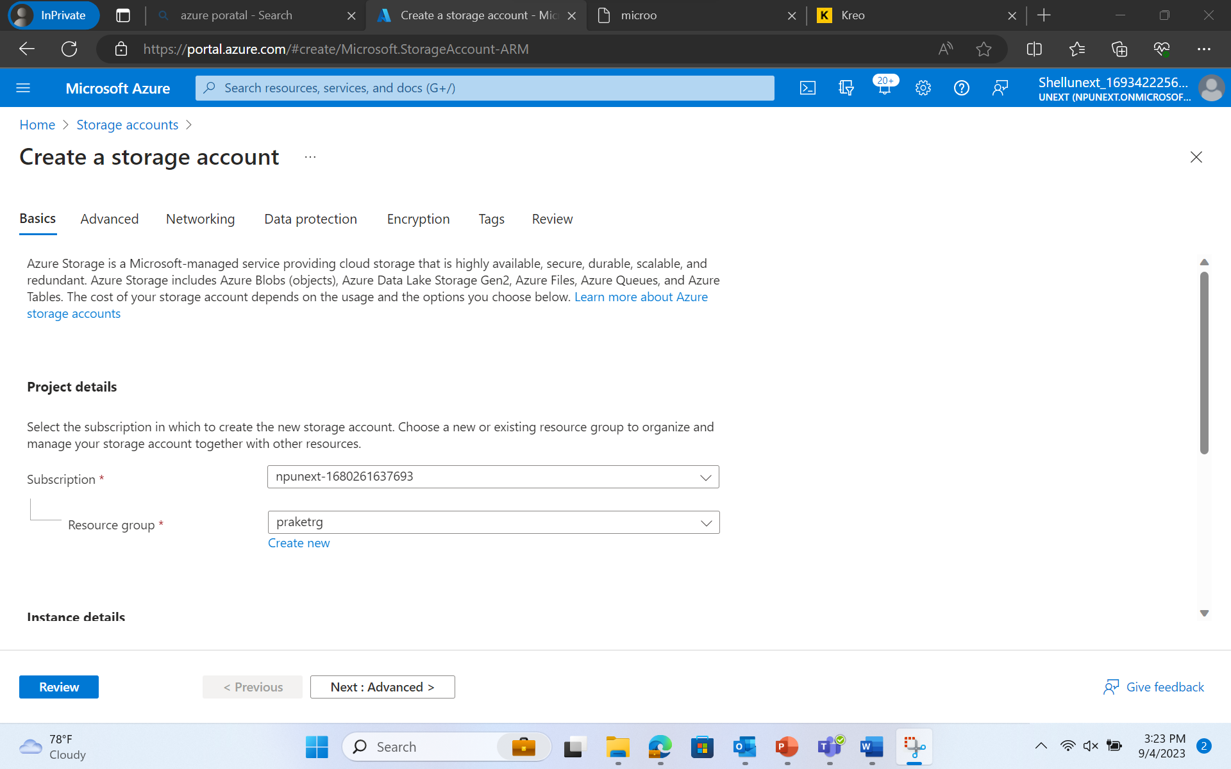

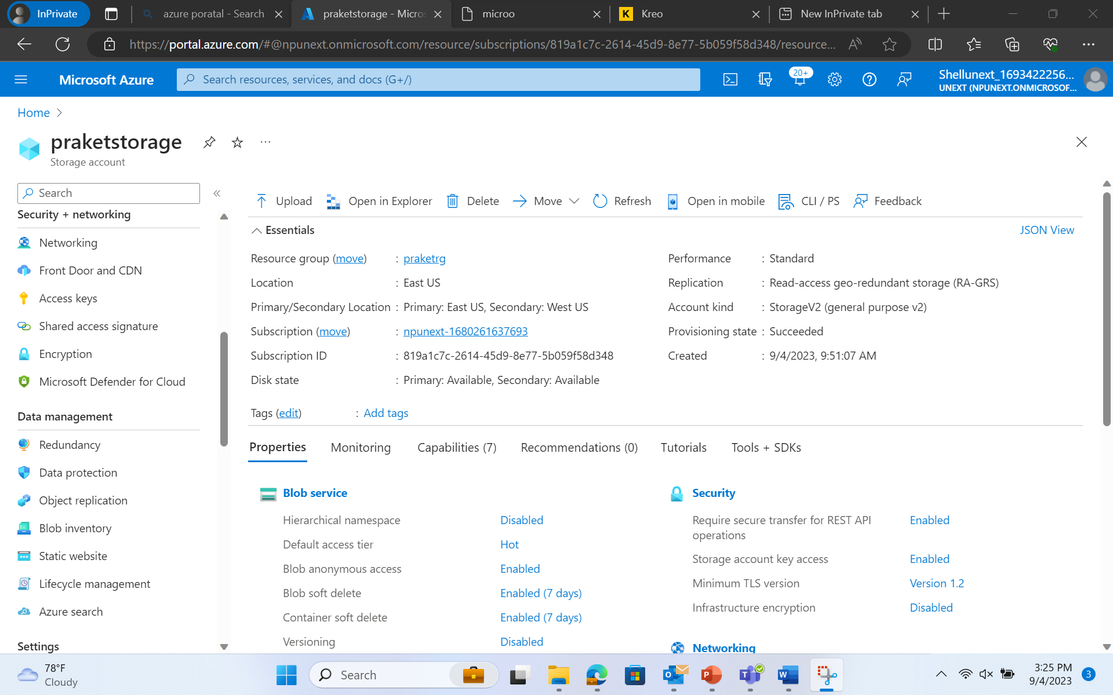

Static Website -

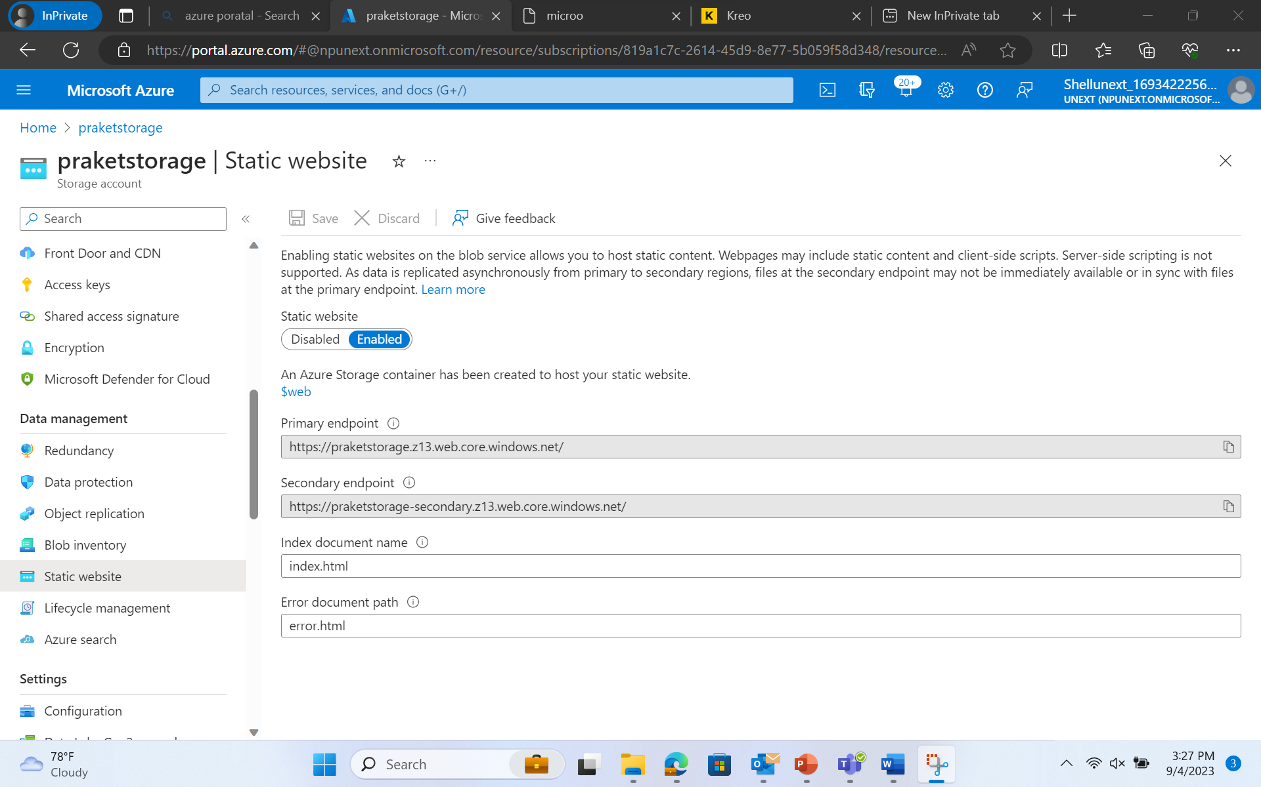

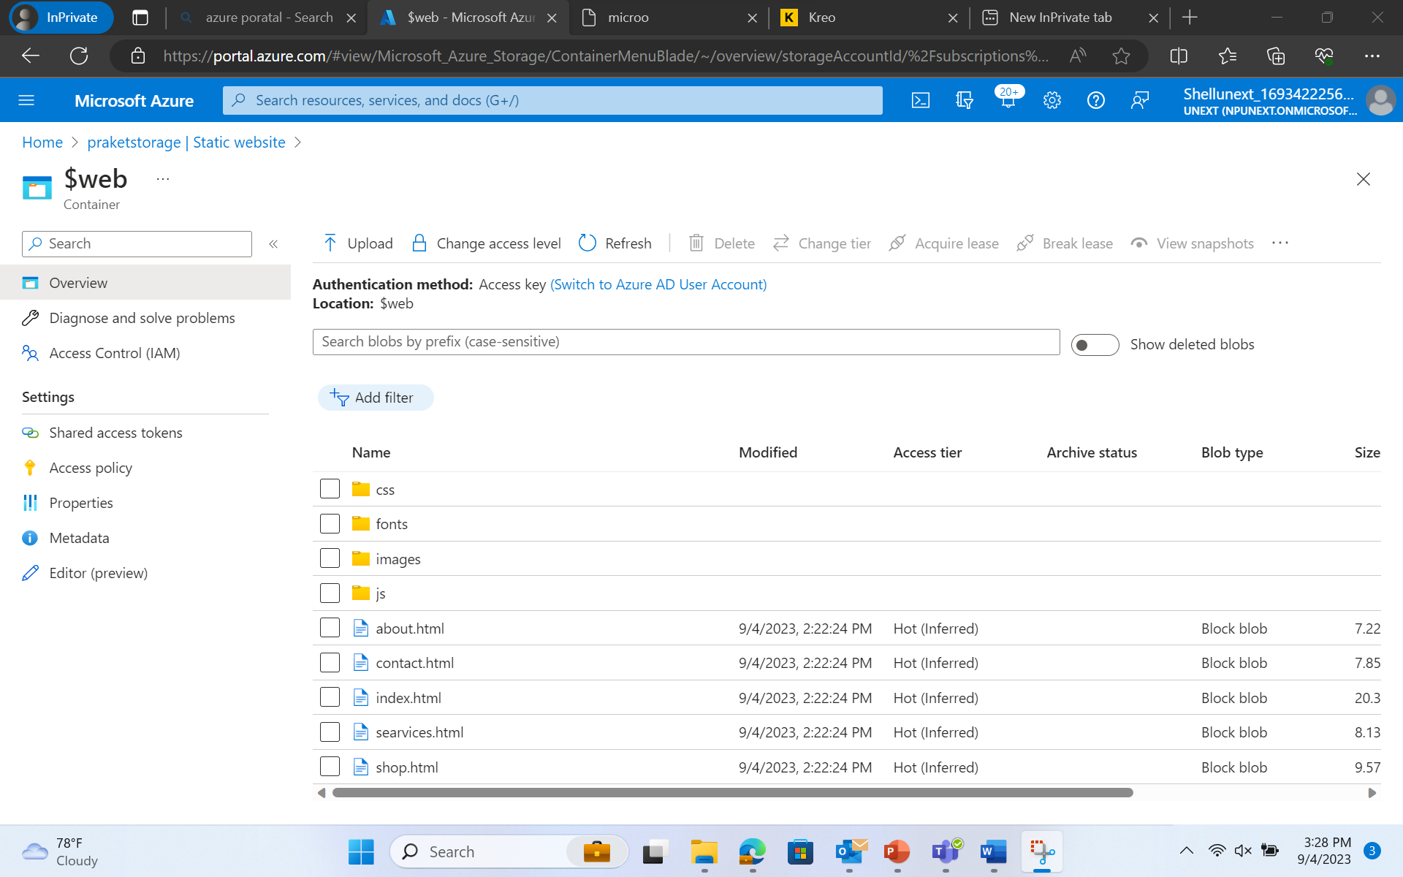

Result -



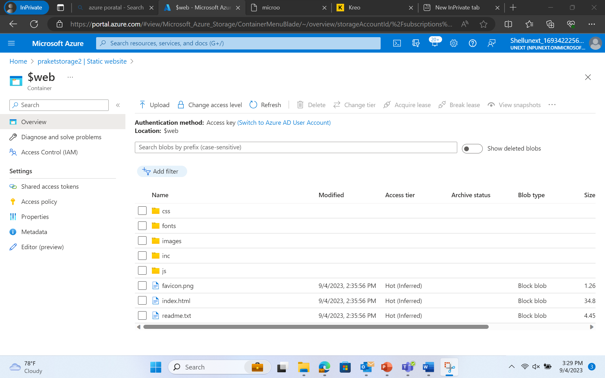

Result of above deployment –

